|  |
| --- |
| CURRICULUM VITAE |

Aagershini Nadesalingam

|  |
| --- |
| * CONTACT DETAILS :- |

***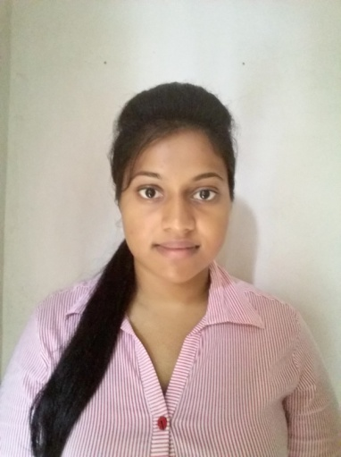****n.aagershini*

*# 22/5b asarappa road,*

*negombo*

*sri lanka*

* E-MAIL ID

[***aagershini@gmail.com***](mailto:aagershini@gmail.com)

* CONTACT NO

MOBILE: +94 75 5658709

|  |
| --- |
| * Purpose :- |

* I am an energetic and enthusiastic person who enjoys challenges and achieving personal goals. My present career aim is to work as a trainee in the human resource management because I enjoy working in field and also I find the work interesting. The opportunity utilizes to learn new skills in customer service and administrative role.

|  |
| --- |
| * PERSONAL DETAILS :- |

* NAME IN FULL : Aagershini Nadesalingam
* NATIONALITY : SRI LANKAN
* DATE OF BIRTH : 17TH OF July 1995
* GENDER : Female
* CIVIL STATUS : SINGLE
* National ID Card No. : 956993890V

|  |
| --- |
| * EDUCATIONAL QUALIFICATIONS :- |

* EDEXCEL I.G.C.S.E LONDON (O/L) EXAMINATION (2011)
* SCHOOL ATTENDED: NEGOMBO SOUTH INTERNATIONAL SCHOOL.

RESULTS

Biology

Chemistry

Mathematics

Physics

Human biology  
English

A

A

B

B

B

C

* EDEXCEL G.C.E LONDON (A/S) EXAMINATION (2012-13)
* SCHOOL ATTENDED: NEGOMBO SOUTH INTERNATIONAL SCHOOL.

results

Mathematics

C

D

E

Chemistry

Biology

|  |
| --- |
| * PROFESSIONAL QUALIFICATIONS :- |

* Diploma In Indian & Foreign Accounting
* YEAR : 2013
* Course Followed at : GTEC gamma abacus
* Dual HND in Business Management & HR
* YEAR : 2014-2015
* Course Followed at : ICBT Campus
* Results : Pending

|  |
| --- |
| * Key Skills:- |

* Computer – MS Office Suite, MS Project and ERP management
* Good knowledge in Accounting Software such as Tally, QuickBooks and Peachtree
* Able to speak in English, Sinhala and Tamil
* Experienced in being a prefect for 3 years
* Confident attitude with a proactive approach to work
* Profound knowledge about management issues
* Strong written and verbal communication skills
* Good analytical and presentation skills
* Ability to interact with a diverse set of people
* Able to manage multiple tasks simultaneously

|  |
| --- |
| * Interests |

* Socializing with friends and family
* Reading Non-Fiction books
* Web browsing
* Listening to music

|  |
| --- |
| * References:- |

* Will be available on request